
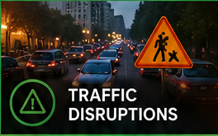



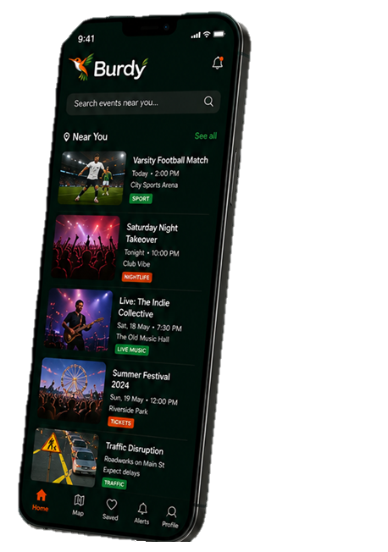

















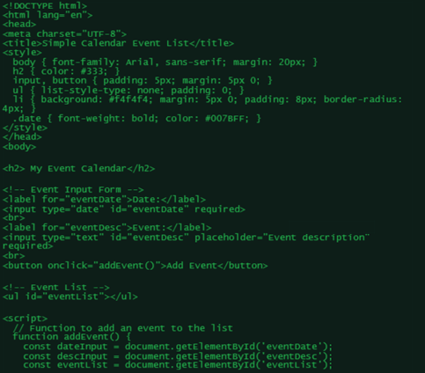






SCAN HERE

GET THE BURDY ADVANTAGE
Use live customer data and trending socials to make your business smarter with real market insight
CROSS MARKET PERFROMANCE
PRODUCT IMPACT
ALERTS AND NOTIFICATIONS
SMARTER ROTA PLANNING
REAL TIME MONITORING
DEMAND FORECASTING
BETTER ROTAS.
MORE SALES.
All the events, footfall drivers and local insights you need – in one powerful platform
Know what’s happening. Understand market demand. Optimise your rota. Maximise sales.
Burdy gives your business the real time edge.
DATA. DELIVERED.

LIVE INSIGHTS AND UPDATES
100+ CATEGORIES COVERED
50,000+ VENUES AND BUSINESSES
1,000,000+ EVENTS TRACKED
IN PARTNERSHIP WITH
KNOW MORE. PLAN BETTER. SELL MORE
DEEPER INSIGHT.

